Mail server for ibm.com and wipro.com

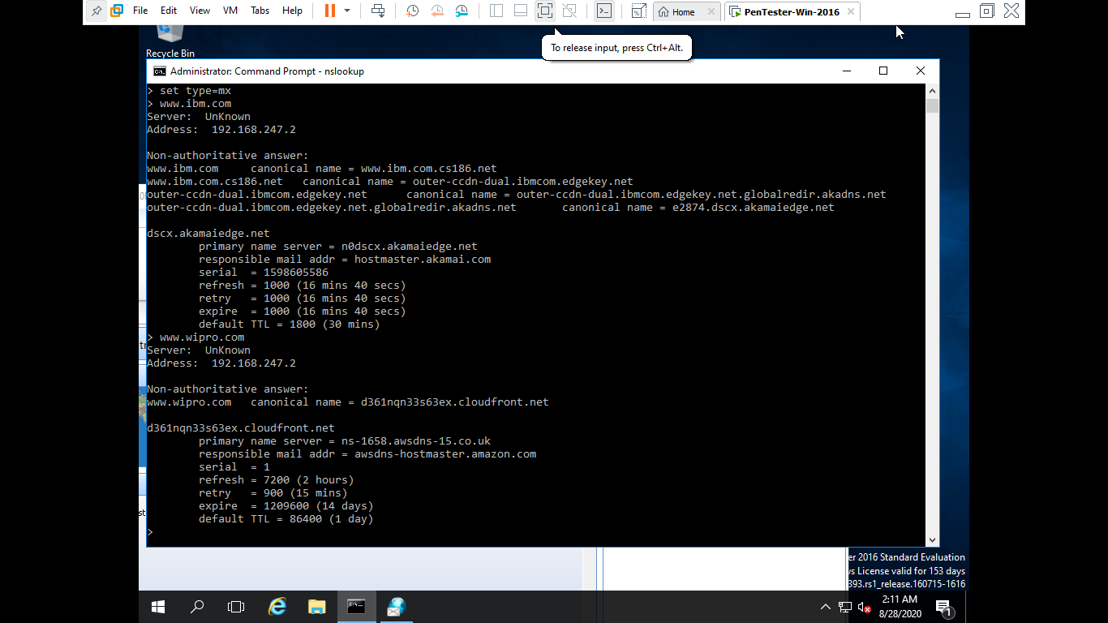

Email location tracking

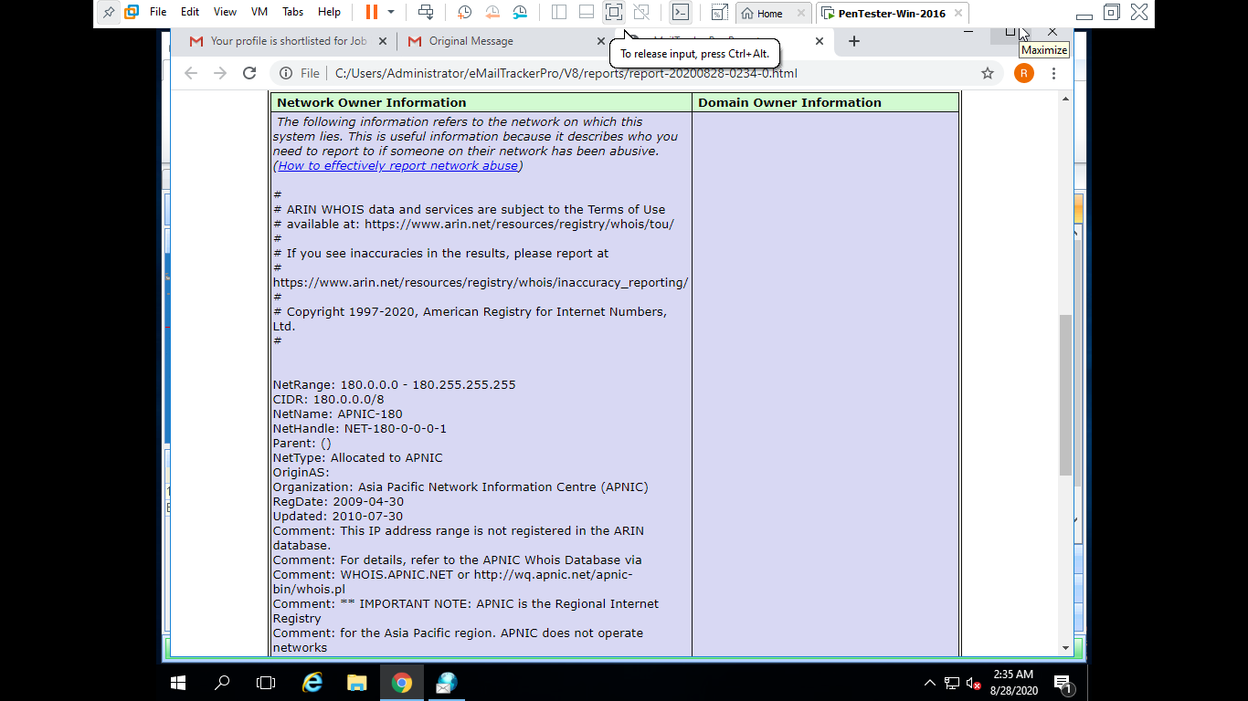

Nmap- Its not showing the details properly

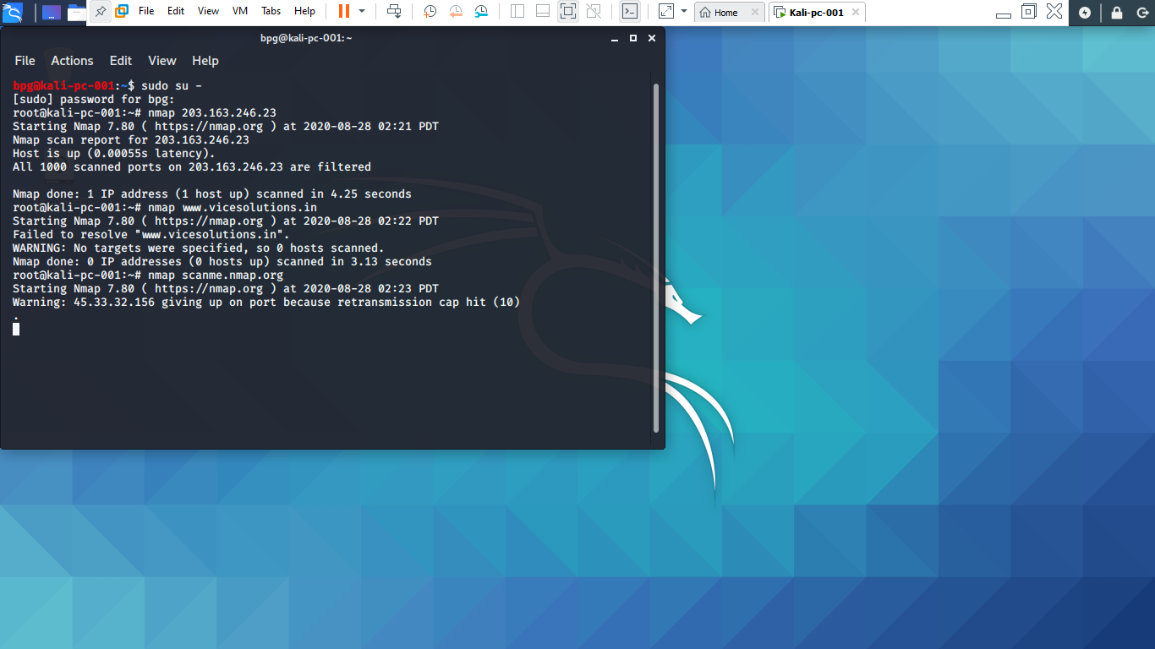

Nessus couldn’t install as I don’t have any professional email id.